Mason Deja

Mod 9

Animal fats and breast cancer

There is a positive association shown in the scatter plot that shows that there is a moderately strengthened correlation between animal fat intake per day and death rate. The scatter plot also does not have any outliers

North fish creek discharge

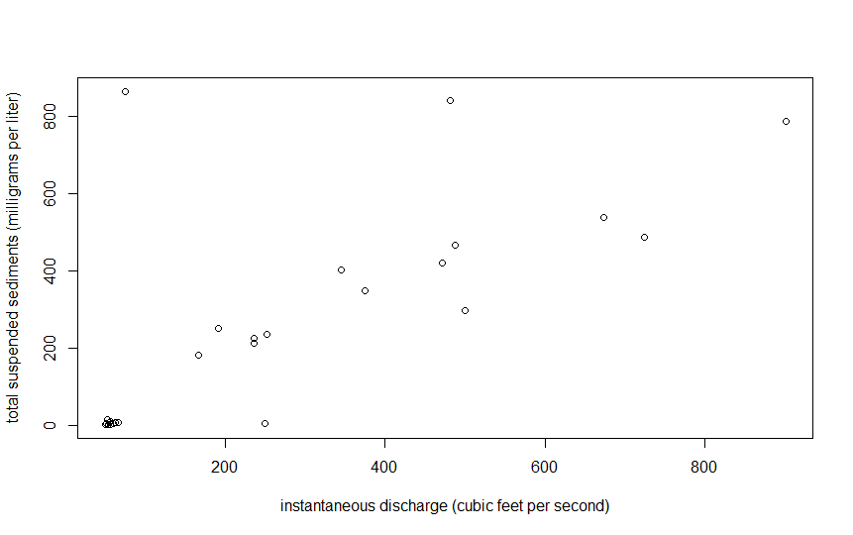

Figure 1. Scatter plot of 28 recorded discharge and suspended sediments events in North fish creek near Ashland, Wisconsin from May/25/1989 to October/15/2002.

There is a positive association between total suspended sediments and instantaneous discharge shown in Figure 1. There is a weak correlation due to many outliers in the plot but if the outliers were to be taken out of the mix there would be a strong correlation.

R script

library(NCStats)

setwd("~/R stuff")

df<- read.csv('FishCrNWaterQuality.csv')

plot(SuspSed~DschrgCFS, data = df,ylab = "total suspended sediments (milligrams per liter)", xlab= "instantaneous discharge (cubic feet per second)")

I have neither given nor received unauthorized aid in completing this work, nor have I presented someone else's work as my own.